Application of CNN Model for Early Detection of Tuberculosis in Chest X-ray Images

Nashiruddin Alif Alvareezi
Biomedical Engineering Dept.
Telkom University
Purwokerto, Indonesia nashiruddinalif@student.telkomuniversity.ac.id
Sevia Indah Purnama Biomedical Engineering Dept Telkom University Purwokerto, Indonesia
seviaindah@telkomuniversity.ac.id
Dodi Zulherman Biomedical Engineering Dept Telkom University Purwokerto, Indonesia
zulherman@telkomuniversity.ac.id

Abstract—Tuberculosis (TB) remains a major health crisis that demands faster and more accessible diagnostic tools. While a chest X-ray (CXR) is a standard screening method, its accuracy is often limited by the availability of radiologists and their subjective judgment. This study evaluates a DenseNet121-based CNN for binary classification of TB using 4,784 local CXR images from a pulmonary hospital in Indonesia. We conducted five experiments to address common deep learning pitfalls, specifically overfitting and class imbalance. Our initial tests showed that training from scratch without regularization led to poor generalization. However, by integrating ImageNet transfer learning, a ReduceLROnPlateau scheduler, and class weighting, we achieved a more reliable model with an AUC of 0.7778. Grad-CAM visualizations further confirm that the model identifies clinically relevant lung pathologies. These results suggest that with the right tuning, deep learning models can serve as effective diagnostic aids in resource-constrained medical settings.

Keyword—uberculosis, Chest X-Ray, DenseNet121, Trans-fer Learning.
- Introduction
Globally, tuberculosis (TB) persists as one of the foremost infectious disease threats confronting healthcare systems. It disproportionately affects populations in low- and middle-income countries, where early diagnosis and treatment access remain underdevelopment. Based on the WHO Global Tuber-culosis Report 2022, an estimated 10.6 million new TB cases and 1.6 million deaths were recorded in 2021 [1]. Critically, a substantial proportion of TB cases in high-burden settings remain undetected or unreported. This diagnostic gap sustains community transmission, underscoring the urgent need for scalable, reliable screening tools that can operate effectively outside well-resourced clinical environments.
Chest X-ray (CXR) imaging occupies a central role in pulmonary TB screening due to its broad availability, rela-tively low cost, and rapid results. Several CXR features are associated with active pulmonary TB, including upper-lobe infiltrates, cavitation, and consolidation. However, its analysis relies on subjective pattern recognition, and the reliability of that process is tightly coupled to the interpreting clinician’s expertise [2]. Consequently, it consistently documented sig-nificant inter-observer variability under such conditions [3],
The financial support of this study is Telkom University Grant Number 6142/LIT06/PPM-LIT/2026.
leading to both underdiagnosis and overdiagnosis. These short-comings highlight a critical need to supplement or augment human reading with objective, automated methods.
Meanwhile, convolutional neural networks (CNNs) have emerged as promoting approach to support medical image interpretation. CNNs model learns visual representations end-to-end from raw pixel data, building increasingly abstract features across successive layers [4]. CNNs have demon-strated strong performance across medical imaging tasks such as classification, detection, and segmentation across diverse modalities [5]. In [6], they demonstrated that CNN-based classifiers could achieve diagnostic accuracy comparable to that of trained radiologists. Then, [7] explored more complex architectural to capture the nuanced CXR patterns associated with active TB, including early-stage or atypical presentations. Importantly, the strength of the CNN model lies not merely in achieving high aggregate accuracy but in its potential to standardize diagnostic performance, especially for TB screen-ing. However, many published studies rely on small, curated benchmark datasets that may not reflect the variability inherent in clinical practice, and performance metrics are frequently reported without adequate analysis of class imbalance.
DenseNet121, a CNN model introduced by [8], has been established as a well-suited model for medical image clas-sification tasks. The architectural innovation offers several advantages for training on limited medical datasets, including vanishing gradient mitigation, aggressive feature reuse, and reduced overall parameter count compared to architectures of similar depth. The landmark CheXNet study in [9] brought DenseNet121 to widespread prominence in the CXR com-munity by demonstrating good performance for pneumonia detection on a large-scale frontal view dataset. Building on this precedent, [10] applied DenseNet121 to TB classifica-tion tasks, reporting sensitivity and specificity values suffi-cient for consideration as a screening-level tool. However, they employed transfer learning from ImageNet-pretrained weights, which introduces implicit biases from non-medical images and limits interpretability regarding what the model has actually learned from radiological data. Additionally, a persistent challenge in applying DenseNet121 for detecting TB is the availability of large, well-annotated chest X-ray datasets. Several public datasets have been made available for research

purposes, including the Shenzhen and Montgomery County datasets released by the National Library of Medicine [11], which have served as foundational benchmarks. However, their limited scale poses a genuine risk of overfitting when training high-capacity models like DenseNet121 without additional mitigation strategies. Data augmentation, encompassing spatial transformations such as random flipping and rotation, intensity perturbations, and noise injection, has been widely adopted to artificially expand the effective training set size and im-prove generalization [12]. While fine-tuning from ImageNet-pretrained weights is the dominant paradigm in medical image deep learning. A model trained on CXR data is unconstrained by low-level feature biases inherited from natural photography [13]. Despite these motivations, understanding of how much of DenseNet121’s empirical success on CXR tasks is attributable to its architecture versus its initialization. This study directly addresses that gap.
The clinical utility of a DenseNet121-based TB screening system depends not only on overall accuracy but also on its sensitivity and specificity. A high-sensitivity DenseNet121 model minimizes missed TB cases (false negatives), which is critical for limiting disease transmission, while high specificity reduces unnecessary follow-up procedures and patient anxiety [14]. Despite considerable progress in applying DenseNet121 to chest X-ray analysis, several research gaps remain, par-ticularly in TB detection. First, relatively few studies have rigorously evaluated DenseNet121 trained from scratch rather than fine-tuning for TB classification. Second, augmentation configurations impact on DenseNet121’s TB classification performance has not been thoroughly characterized. Third, many existing DenseNet121-based studies report results on a single dataset, raising questions about cross-dataset gener-alizability [15]. The main contributions of this study are as follows: 1) to implement DenseNet121 trained from scratch for binary classification of TB without reliance on pretrained weights, 2) to analyze the effect of batch size tuning and reduceLRonPlateau strategies on DenseNet121’s performance.
- Methodology
- Dataset
We utilized a total of 4,784 Chest X-Ray images directly from a local pulmonary hospital in Indonesia giving the study a bit more real-world weight compared to just using public datasets. We split these images into a 70:15:15 ratio for training, validation, and testing, respectively. All chest X-ray (CXR) images are preprocessed prior to model training to ensure consistency and compatibility with the network architecture. Each image is resized to 224 × 224 pixels to match the input requirements of DenseNet121. Pixel intensity values are normalized to the range [0, 1] by ImageNet to improve numerical stability during training. Since the original CXR images are grayscale, each image is converted to a three-channel format by duplicating the single channel to conform to the model’s input structure. Regarding data augmentation, it is applied selectively during the advanced stages of the exper-iment. To establish a baseline and evaluate the model’s perfor-

Chest X-ray Dataset
Preprocessing (Resize, Normalization, Channel Conversion)
Dataset Split (Train / Validation / Test)
DenseNet121 Training
Experiments (Batch Size: 4, 8, 16
+ Augmentation in Exp-4 & 5)
Evaluation
Metrics Accuracy, Precision,
Recall, F1-score Confusion Matrix, ROC Curve

Fig. 1: Proposed research workflow for CXR-based tubercu-losis classification.

mance based purely on the original dataset distribution without artificially increasing data variability, no data augmentation was used in the first three experiments (Experiments 1, 2, and 3). However, data augmentation techniques such as random horizontal flip, random rotation, and random resized crop were introduced in the fourth and fifth experiments to enhance the model’s generalizability and mitigate the overfitting observed in the earlier configurations.
- Research Workflow
The overall research workflow in this study comprises sev-eral stages: dataset preparation, preprocessing, model training, experimental configuration, and performance evaluation. The workflow is designed to systematically develop and evaluate a deep learning model for the early detection of tuberculosis using chest X-ray images. Figure 1 illustrates the research flow of this study.
Initially, the CXR dataset is collected and organized into two classes, namely TB and Non-TB. Then, the dataset is preprocessed to ensure compatibility with the convolutional neural network model. In this stage, each image is resized to 224 × 224 pixels and min-max normalized to improve training stability. Next, the dataset is divided into training, validation, and testing sets. The training dataset is used to train the DenseNet121 model, while the validation dataset is used to monitor the learning process.
To analyze the impact of batch size on model performance, several experimental configurations are conducted using differ-ent batch sizes while maintaining the same learning rate and optimizer. Finally, the trained model is evaluated using the testing dataset. Performance metrics such as accuracy, preci-sion, recall, F1-score, ROC Curve and confusion matrix are

used to assess the classification performance of the proposed system.
- Model Architecture
We chose DenseNet121 because of its efficiency in reusing features through dense connections, which is particularly use-ful when working with medical datasets that aren’t massive in scale. We tested its limits by training it from scratch before eventually shifting to a transfer learning approach. To make the model more robust, we applied a series of augmentations like random rotations and flips, simulating the slight variations in patient positioning that occur in real-world clinical environments. The training process is performed using the Adam optimizer due to its ability to adaptively adjust learning rates and improve convergence stability during deep neural network training. The learning rate is set to 5 × 10⁻⁵, and Binary Cross-Entropy (BCE) loss is used as the objective function for the binary classification task between TB and Non-TB classes.
In this study, the use of transfer learning is applied exclu-sively in the fifth experiment (Experiment 5). For Experiments 1 through 4, the DenseNet121 model was trained from scratch without using any pretrained weights. This approach was designed to evaluate the baseline performance of the model learning solely from the provided dataset. To evaluate the influence of batch size on the model performance, Experiments 1, 2, and 3 were conducted using different configurations while keeping the dataset partition, preprocessing pipeline, and optimizer consistent. The model is trained for 30 epochs in each experiment, with varying batch sizes of 4, 8, and 16, respectively. In addition, an extra experiment (Experiment 4) is conducted with a higher learning rate of 3×10⁻⁴ to investigate the effect of learning rate variation on model performance while keeping the batch size and number of epochs consis-tent with Experiment 2. Furthermore, Experiment 4 incorpo-rates data augmentation techniques and a ReduceLROnPlateau learning rate scheduler to mitigate severe overfitting observed in the earlier experiments. The data augmentation techniques include random horizontal flipping, slight random rotations, and random resized crops to increase dataset variability and improve generalizability. Finally, Experiment 5 incorporates transfer learning by initializing the DenseNet121 model with pretrained weights from the ImageNet dataset. To address the class imbalance between the Tuberculosis and Normal cases, class weighting is implemented in the loss function. This final configuration maintains the same batch size, learning rate (3 × 10⁻⁴), learning rate scheduler, and data augmentation techniques as Experiment 4 to allow a consistent evaluation. The detailed training configurations used in this study are presented in Table II.
During the training process, training and validation accuracy as well as loss values are recorded at each epoch to monitor the learning progress and detect potential overfitting. All experiments are implemented using the PyTorch deep learning framework and executed in a GPU-enabled environment to accelerate the training process.
TABLE I: Training Experiment Configuration

Experiment | Batch Size | Epoch | Learning Rate | Optimizer
Exp-1 | 4 | 30 | 5 × 10⁻⁵ | Adam
Exp-2 | 8 | 30 | 5 × 10⁻⁵ | Adam
Exp-3 | 16 | 30 | 5 × 10⁻⁵ | Adam
Exp-4 | 8 | 30 | 3 × 10⁻⁴ | Adam
Exp-5 | 16 | 30 | 3 × 10⁻⁴ | Adam

- Result and Discussion
This section presents a comprehensive analysis of the results obtained from five distinct training experiments (Exp-1 through Exp-5), which were systematically conducted by varying the batch sizes and learning rate configurations. To provide a rigorous assessment of performance, the models were evaluated using a diverse set of metrics, including accuracy, precision, recall, and the F1-score. These metrics are reported for both the Tuberculosis (TB) and non-Tuberculosis (non-TB) classes, ensuring a detailed understanding of the model’s discriminative capability and its consistency across an imbalanced dataset.
- Batch Size Effect on Model Performance
The first experiment until third experiment was conducted using a batch size variety with a learning rate of 5 × 10⁻⁵. The model was trained for 30 epochs from scratch, without the use of pretrained weights or data augmentation. Figure 3 shows the comparison of training and validation accuracy, while figure 2 illustrates the model loss comparison between each batch size. Furthermore, table II and figure 4 shows the model performance comparison based on metric performance.
The comparison between training loss and validation loss, as shown in Figure 2, demonstrates that batch size signifi-cantly affects model performance and generalization capabil-ity. Among the experiment set up, the model using batch size 4 showed the smallest degree of overfitting, indicated by a relatively smaller gap between the training and validation loss curves. In contrast, larger batch sizes, particularly 8 and 16, exhibited stronger divergence between training and validation loss during later epochs, suggesting weaker generalization performance. A similar pattern was observed in the training
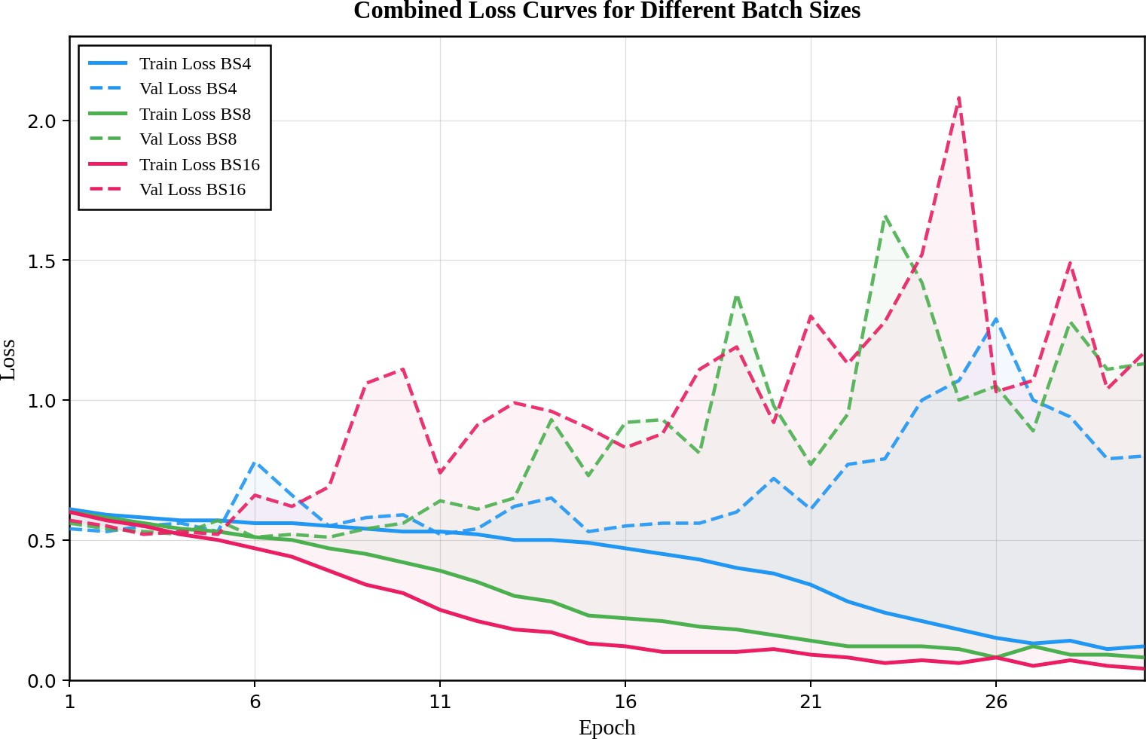
Fig. 2: Batch Size Effect on Training and Validation Loss

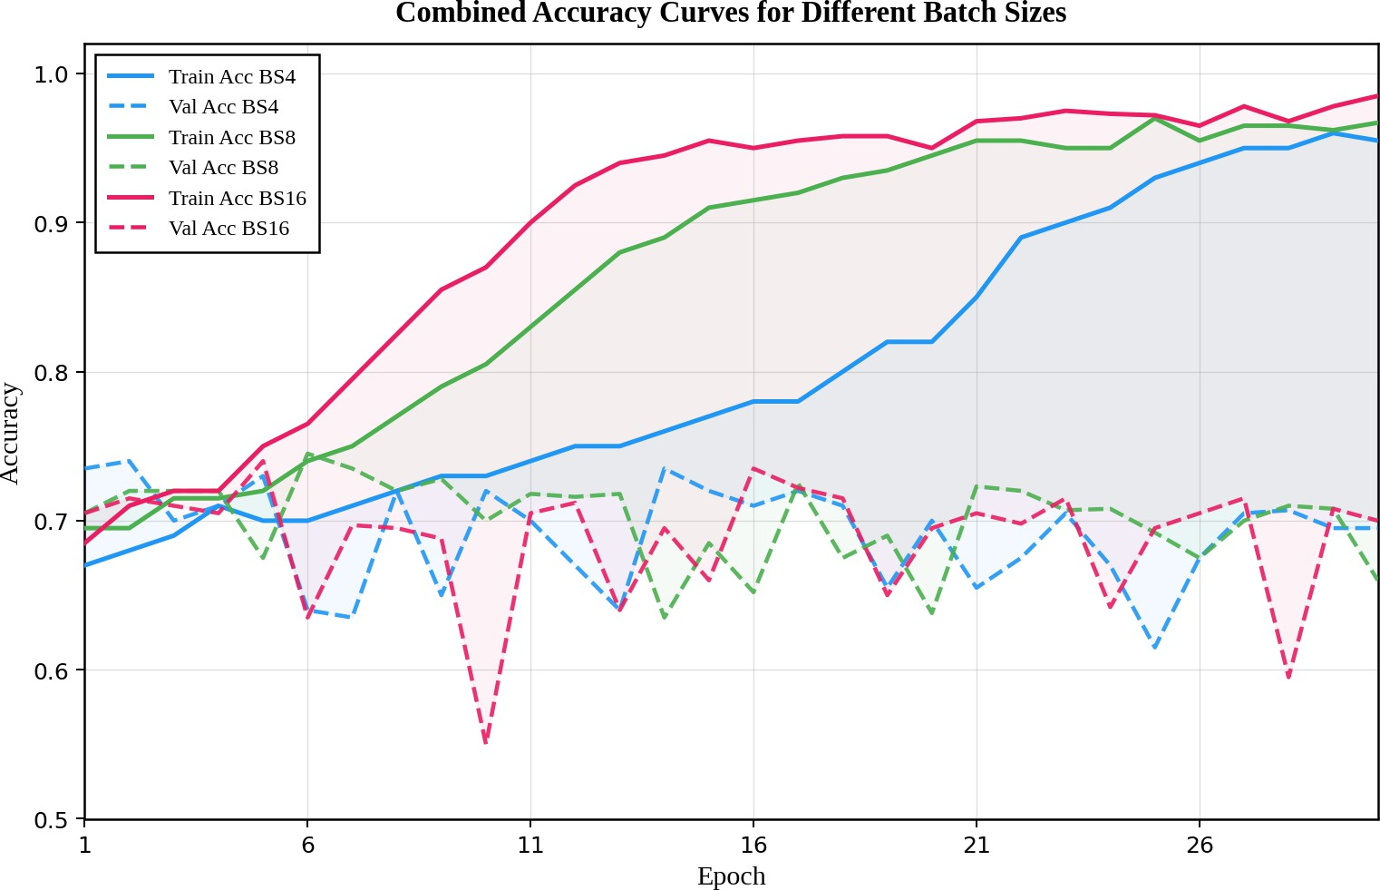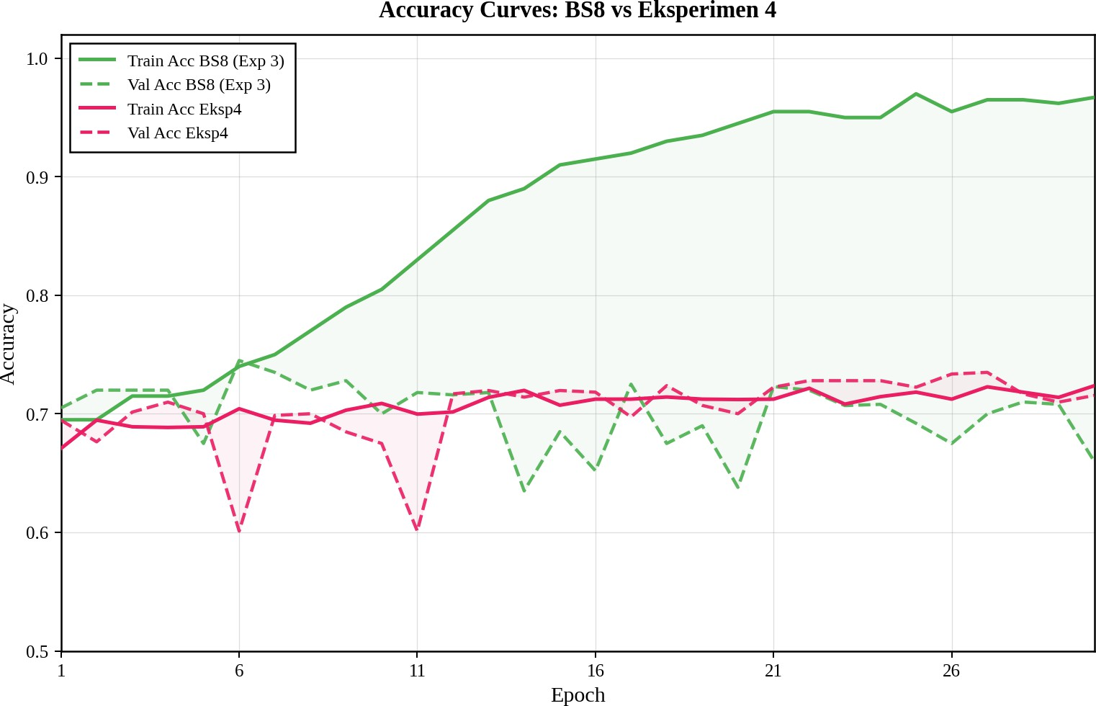

Fig. 3: Batch Size Effect on Training and Validation Accuracy
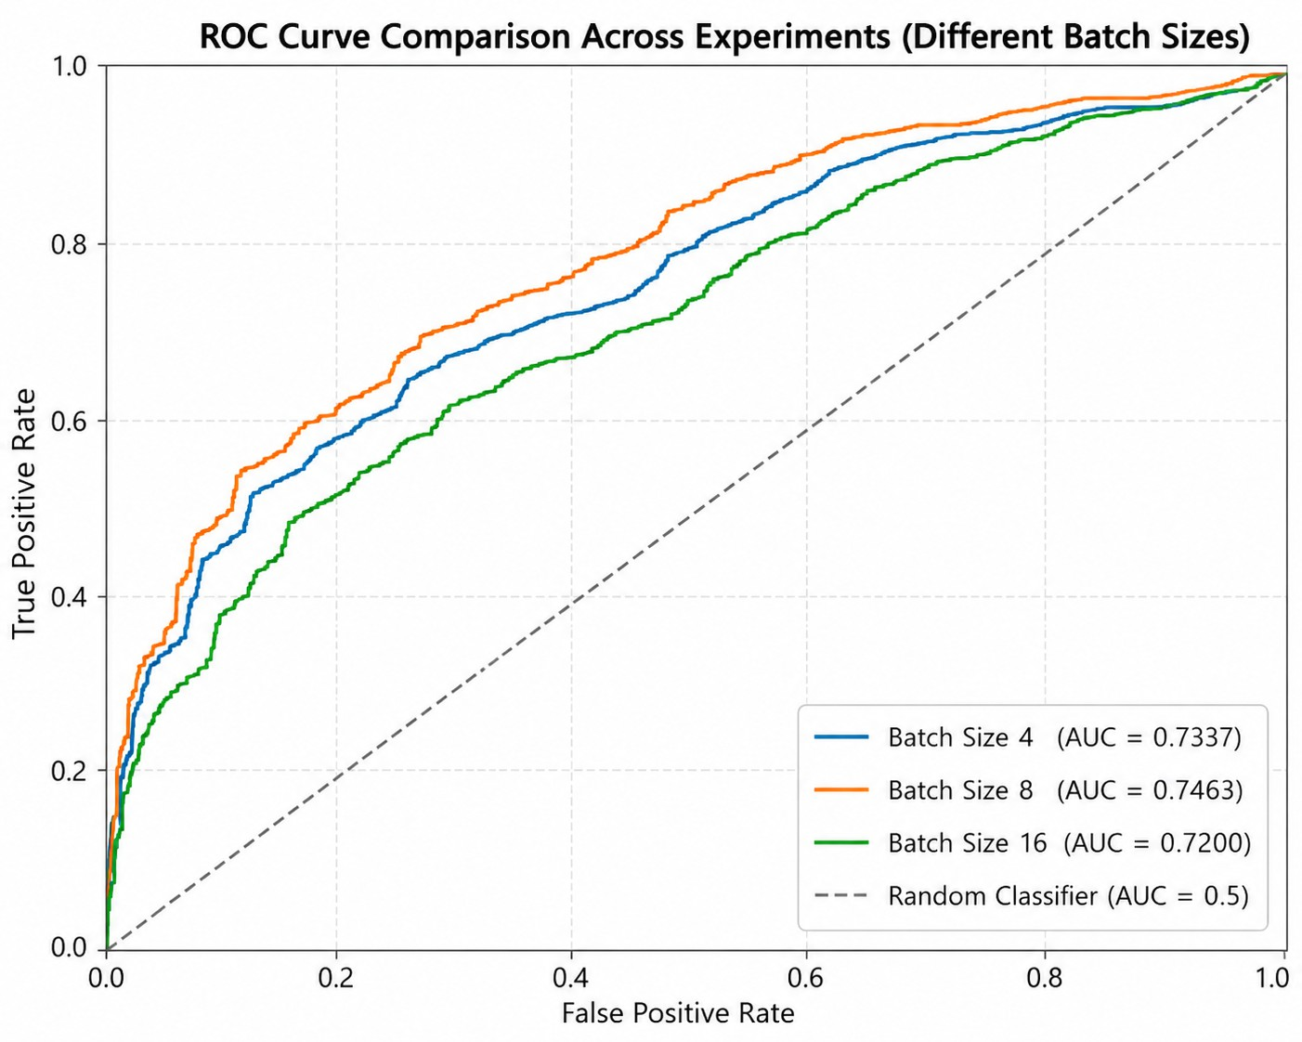
Fig. 4: Batch Size Effect on ROC-AUC

and validation accuracy results, illustrated by Figure 3. Al-though all models achieved training accuracy values above 90%, the validation accuracy remained relatively stable within the range of 65%–70%. This indicates that all models learned the training data effectively but had limited capability in maintaining performance on unseen validation data, reflecting overfitting behavior across all experimental scenarios. Based on overall classification performance metrics presented in Table II, the batch size 4 configuration demonstrated the most balanced and stable performance among the evaluated models. However, the ROC-AUC analysis revealed a different trend, where the batch size 8 model achieved the highest AUC value compared to the other configurations, as shown in Figure 4. This suggests that although batch size 8 experienced stronger overfitting, it provided better discriminative capability in distinguishing between classes. Overall, the results confirm that batch size strongly influences convergence behavior and predictive performance.

TABLE II: Batch Size Effect on Metric Performance
Batch Size | Precision | Recall | F1-Score | Accuracy
4 | 0.69 | 0.70 | 0.68 | 0.70
8 | 0.68 | 0.65 | 0.65 | 0.65
16 | 0.69 | 0.69 | 0.63 | 0.69

Fig. 5: Accuracy Curves Comparison: Exp-3 (BS8) vs Exp-4

- Model with Scheduler Effect
The fourth experiment was conducted using a batch size of 8 with a higher initial learning rate of 3×10⁻⁴, combined with a ReduceLROnPlateau learning rate scheduler. The scheduler was configured to reduce the learning rate by a factor of 0.5 whenever the validation loss did not improve for 3 consecutive epochs, resulting in an automatic learning rate decay from 3 × 10⁻⁴ to 1.5×10⁻⁴ at epoch 17, and then to 7.5×10⁻⁵ at epoch 24. A weight decay of 1 × 10⁻⁴ was also applied to prevent overfitting. Additionally, several data augmentation techniques were applied, including random horizontal flip (50%), random rotation (±10◦), random resized crop with a zoom factor of 0.9–1.0, and ImageNet normalization.
As illustrated in Figure 5, the comparison between Exper-iment 3 (BS8) and Experiment 4 reveals a clear contrast in generalization behavior. In Experiment 3, the training accuracy climbed steeply to 96.7% by epoch 30, while the validation accuracy remained largely stagnant and fluctuated between 63.5% and 74.5%, reflecting a substantial overfitting problem. In Experiment 4, on the other hand, training accuracy stayed in a more modest range and ended at around 72.4%, but the validation accuracy tracked more closely alongside it, peaking at 73.5% at epoch 27. The significantly narrower gap between the two curves in Experiment 4 indicates that the learning rate scheduler, combined with weight decay and data augmentation, was effective in reducing the model’s tendency to overfit the training data. Furthermore, The evaluation results on the test set achieved an overall accuracy of 71%, precision 72%, recall 71%, and F1-Score 67%.
To further evaluate the discriminative power of the model, the ROC-AUC score were computed. As shown in Figure 6, Experiment 4 achieved an AUC score of 0.7766. The AUC score indicates the model’s performance in distinguishing between the Tuberculosis and non-Tuberculosis classes. The AUC score of 0.7766 shows an improvement in discriminative power compared to the previous experiments, demonstrating that the combination of the learning rate scheduler, weight decay, and data augmentation enhances the model’s ability to differentiate between the two classes.

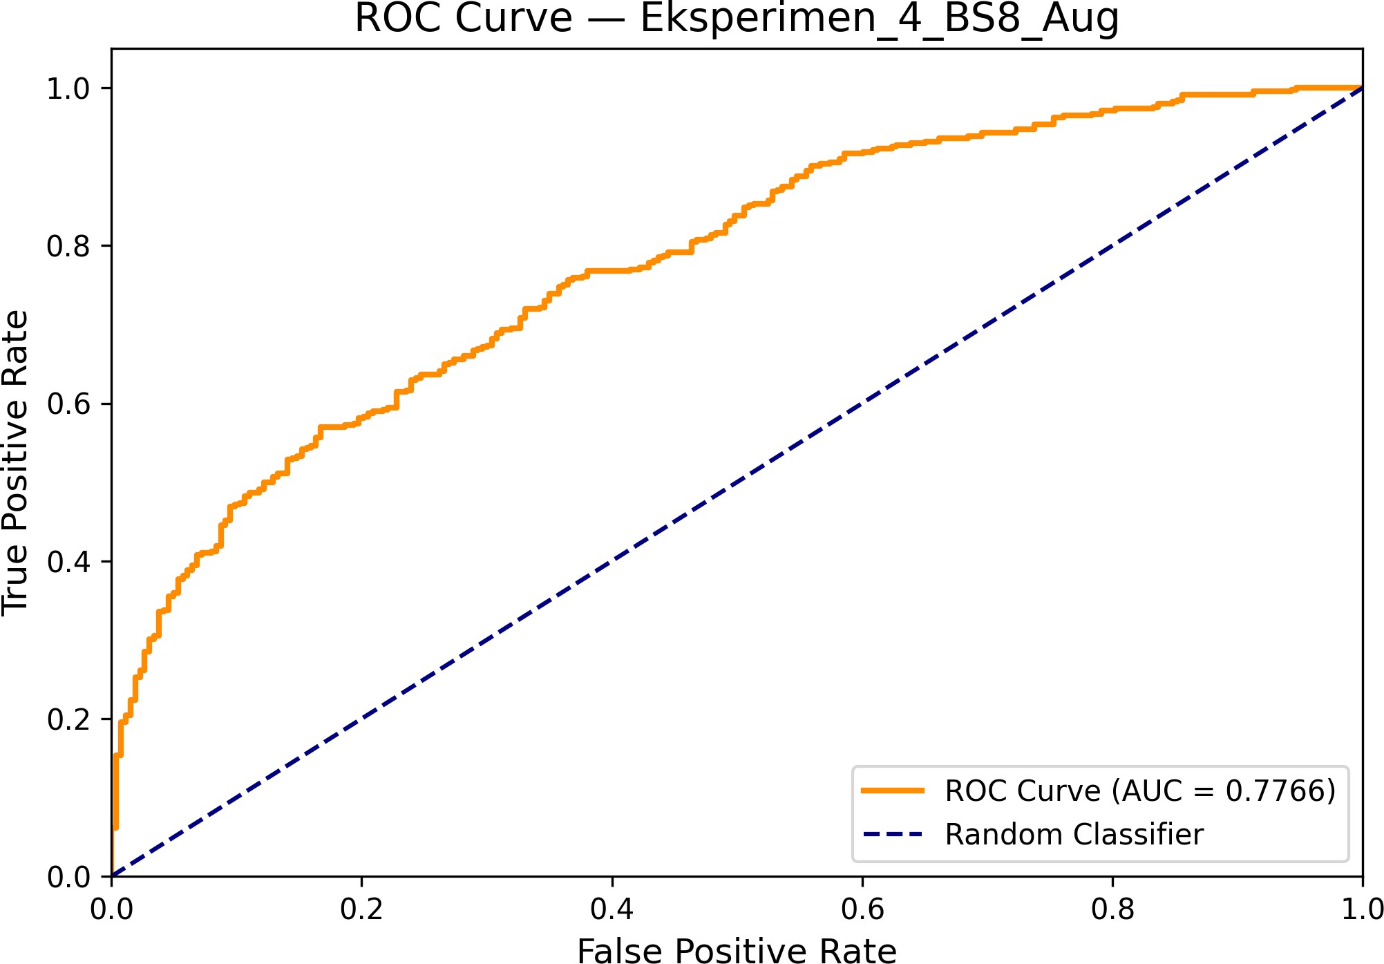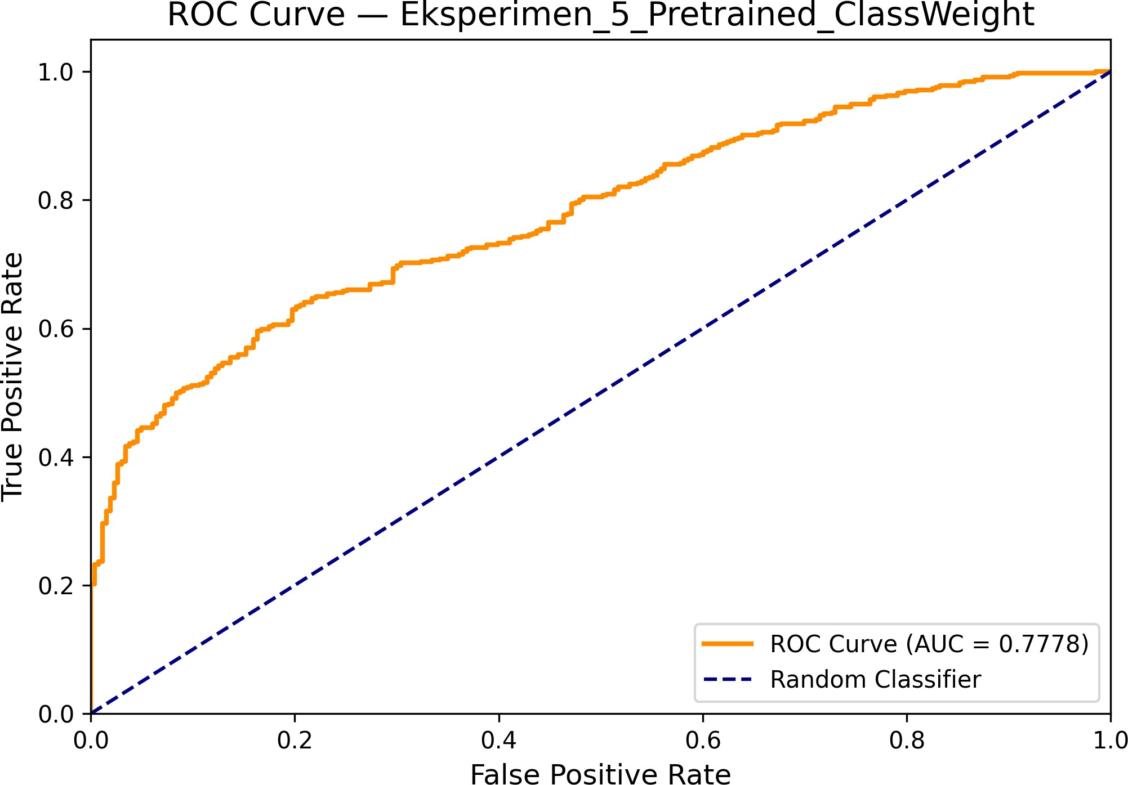

Fig. 6: Roc Curve - Exp-4

- Model with Pretrained Weights and Class Weighting Effect
The fifth experiment (Experiment 5) was designed to further enhance the model’s performance by introducing two critical modifications: the use of Transfer Learning with ImageNet pretrained weights and the implementation of Class Weight-ing in the loss function. While maintaining the successful configuration from Experiment 4—including a batch size of 8, a learning rate of 3 × 10⁻⁴ with a ReduceLROnPlateau scheduler, weight decay of 1 × 10⁻⁴, and data augmentation this experiment focused on addressing class imbalance and improving feature extraction.
Experiment 5 exhibited the most stable and superior training dynamics. The use of pretrained weights allowed the model to converge faster, as it started with learned visual features rather than random initialization. Furthermore, the inclusion of class weights in the CrossEntropyLoss function forced the model to pay more attention to the minority class (Non-TB), effectively balancing the precision-recall trade-off.
Figure 8 shows the accuracy curves of Experiment 3 (BS8) and Experiment 5 placed side by side. The difference in training behavior is quite visible. Experiment 3 produced a training accuracy that climbed sharply to nearly 97% by epoch 30, whereas its validation accuracy stayed flat and volatile throughout, hovering mostly between 63.5% and 74.5%. Ex-periment 5, by contrast, showed a more gradual increase in training accuracy from 61.9% at epoch 1 to 76.9% at epoch 30, with the validation accuracy reaching a peak of 76.0% at epoch 8 and remaining more stable overall. The gap between training and validation in Experiment 5 was considerably narrower than in Experiment 3, suggesting that the combination of pretrained weights and class weighting helped the model generalize better rather than simply fitting the training data. Although the training accuracy of Experiment 5 is lower than that of Experiment 3, this outcome is expected given the stronger regularization applied, and it reflects a more balanced and reliable learning process.
The evaluation results on the test set achieved an overall accuracy of 70%. More importantly, the model showed a significantly more balanced performance compared to previous experiments. The precision for the Non-TB class reached 0.65
Fig. 7: Roc Curve - Exp-5
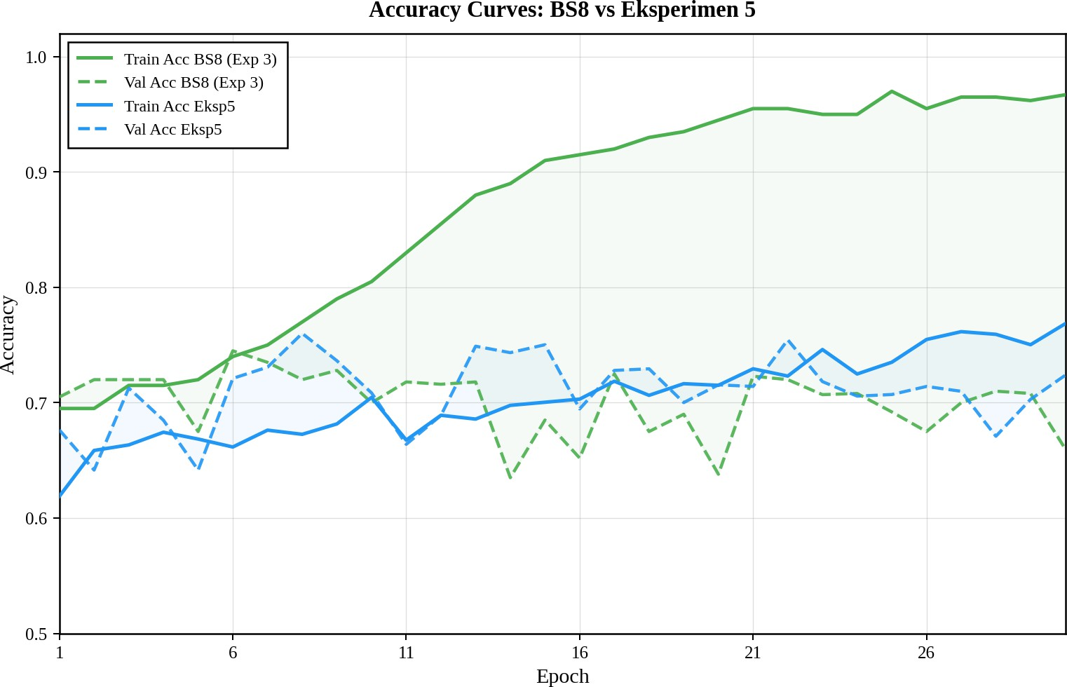
Fig. 8: Accuracy Curves Comparison: Exp-3 (BS8) vs Exp-5

with a recall of 0.39, while the TB class maintained a high recall of 0.88 with a precision of 0.71. Experiment 5 was where everything finally clicked. By adding class weighting to the loss function, we forced the model to stop ignoring the Non-TB cases just because they were outnumbered. This gave us our most balanced results yet, with an AUC of 0.7778. To make sure the model wasn’t just ’lucky,’ we ran it through Grad-CAM. The heatmaps showed exactly what we hoped for: the model was focusing its attention right on the lung abnormalities. Seeing the AI highlight the same areas a human doctor would look at gave us a lot more confidence in the final output.
- Grad-CAM Analysis
To interpret the model’s decision-making process, Gradient-weighted Class Activation Mapping (Grad-CAM) was utilized. Figure 9a and Figure 9b illustrate the regions of interest the model focused on for classification. In TB cases, the model’s attention was concentrated on specific opacities and abnormal-ities within the lung fields, which align with clinical indicators of Tuberculosis. The use of pretrained weights combined with class weighting ensured that the model’s focus remained on relevant anatomical features rather than noise, explaining the overall improvement in reliability and performance.

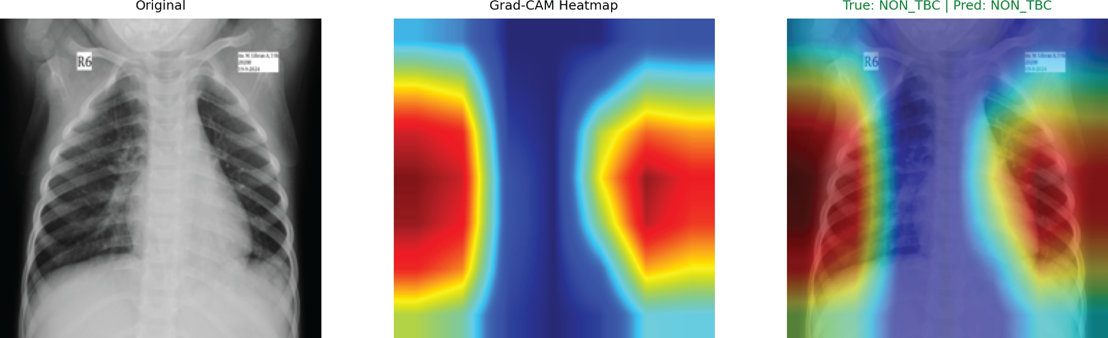
downsampling used to speed up training might have blurred out some of the finer textures that are sometimes key to an early diagnosis.

  - Grad-CAM Visualization for Non-TBC Case
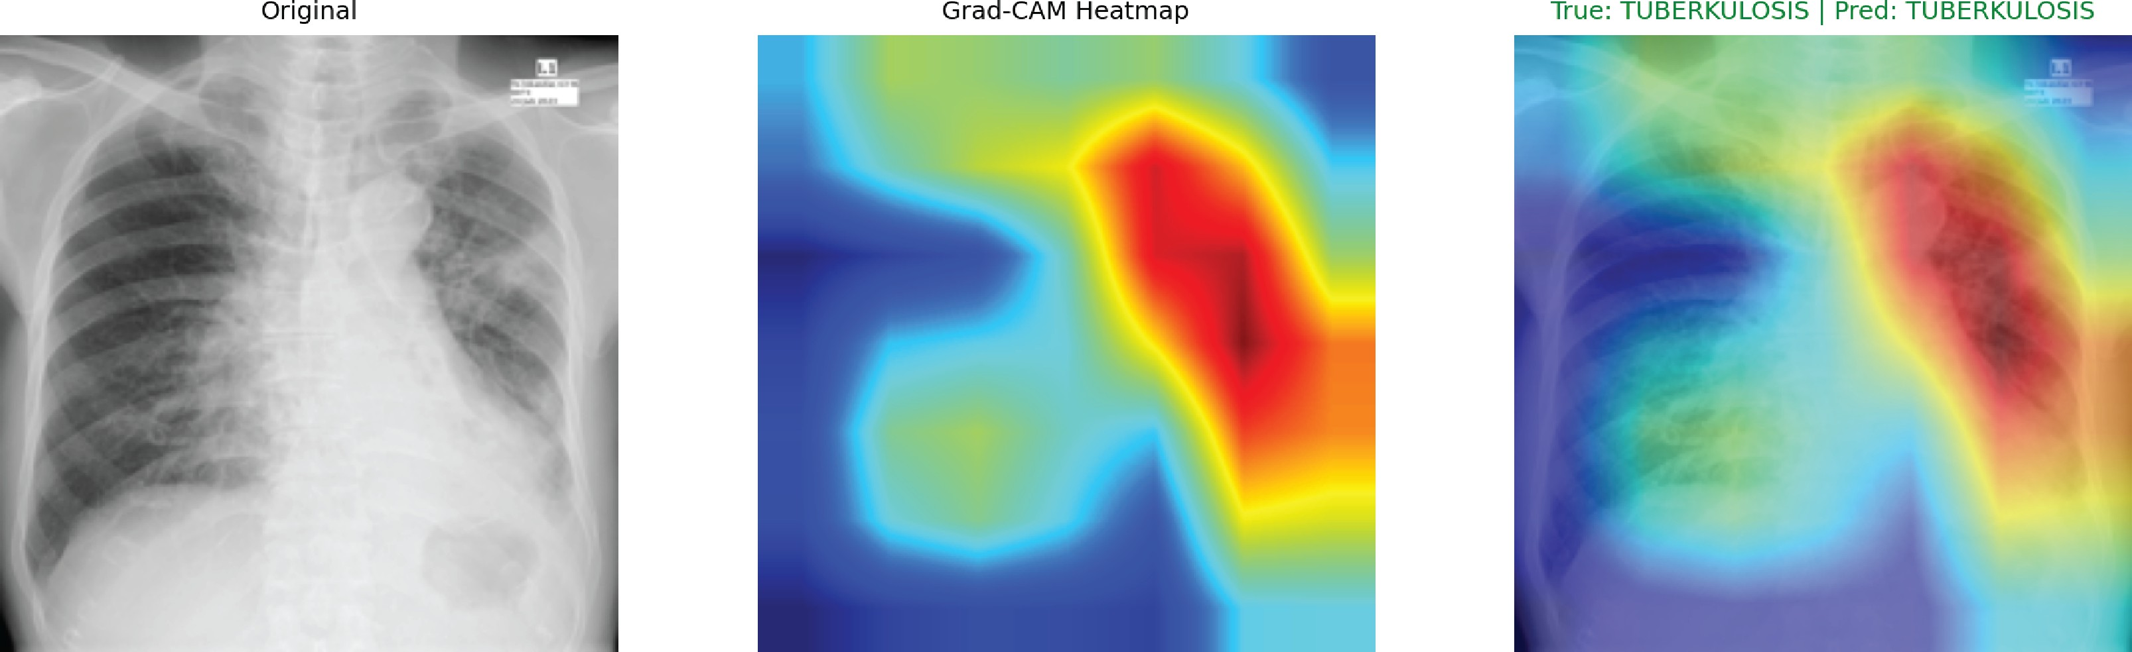
  - Grad-CAM Visualization for TBC Case
Fig. 9: Interpretability analysis using Grad-CAM for both classes in Experiment 5. The heatmaps indicate the regions used by the model to differentiate between classes.

- Discussion
The data from our five experimental stages highlights how much DenseNet121’s performance relies on proper tuning and regularization. Early on, in Experiments 1 through 3, the model failed to generalize, hitting a wall where validation loss spiked after just ten epochs. This clearly shows that when dealing with varied medical imagery, a static learning rate and lack of safeguards simply lead to a model that ”memorizes” rather than ”learns.”
Everything changed in Experiment 4. By introducing ran-dom rotations, flips, and crops alongside a dynamic learning rate scheduler, we forced the network to look for more stable patterns. This stopped the erratic loss curves seen previously and brought the training and validation accuracy into align-ment. Experiment 5 took this further; by leveraging ImageNet knowledge (transfer learning) and forcing the loss function to care more about the underrepresented Non-TB cases (class weighting), we achieved a much more balanced result.
An AUC of 0.7778 in the final setup proves this combo is robust. Crucially, the Grad-CAM maps (Fig. 9) show the model isn’t just guessing based on edges or background noise. It actually ”looks” at the opacities and infiltrates in the lung fields that a radiologist would look for. This bridge between AI logic and clinical reality is what makes the tool potentially useful in a real hospital setting.
There are a few caveats to consider here. First, our data comes from a single Indonesian hospital. This means the model might struggle if deployed in a different region with different X-ray machines or patient demographics. While class weighting helped, the sheer gap in numbers between TB and Non-TB samples still makes the minority class harder to predict perfectly. We also haven’t tested how the model reacts to ”look-alike” diseases like pneumonia or lung cancer yet, as this was a strictly binary study. Lastly, the image
- Conclusion
Our study shows that building a reliable TB classifier isn’t just about picking a deep model like DenseNet121, but about how you manage the training process. Moving from a basic setup to one that uses transfer learning and class weighting significantly boosted stability and resulted in a solid AUC of 0.7778. The fact that Grad-CAM confirms the model focuses on actual lung pathologies is a big step toward clinical transparency. While we need to test this on more diverse, multi-center datasets and include other lung conditions in the future, these results provide a strong framework for automated TB screening in resource-limited areas.
References
- S. Bagcchi, “Who’s global tuberculosis report 2022,” The Lancet Mi-crobe, vol. 4, no. 1, p. e20, 2023.
- A. Zumla, M. Raviglione, R. Hafner, and C. F. von Reyn, “Current concepts,” N Engl J Med, vol. 368, pp. 745–55, 2013.
- M. Van Cleeff, L. Kivihya-Ndugga, H. Meme, J. Odhiambo, and
P. Klatser, “The role and performance of chest x-ray for the diagnosis of tuberculosis: a cost-effectiveness analysis in nairobi, kenya,” BMC infectious diseases, vol. 5, no. 1, p. 111, 2005.
- Y. LeCun, Y. Bengio, and G. Hinton, “Deep learning,” nature, vol. 521, no. 7553, pp. 436–444, 2015.
- G. Litjens, T. Kooi, B. E. Bejnordi, A. A. A. Setio, F. Ciompi,
M. Ghafoorian, J. A. Van Der Laak, B. Van Ginneken, and C. I. Sa´nchez, “A survey on deep learning in medical image analysis,” Medical image analysis, vol. 42, pp. 60–88, 2017.
- P. Lakhani and B. Sundaram, “Deep learning at chest radiography: au-tomated classification of pulmonary tuberculosis by using convolutional neural networks,” Radiology, vol. 284, no. 2, pp. 574–582, 2017.
- F. Pasa, V. Golkov, F. Pfeiffer, D. Cremers, and D. Pfeiffer, “Efficient deep network architectures for fast chest x-ray tuberculosis screening and visualization,” Scientific reports, vol. 9, no. 1, p. 6268, 2019.
- G. Huang, Z. Liu, L. Van Der Maaten, and K. Q. Weinberger, “Densely connected convolutional networks,” in Proceedings of the IEEE confer-ence on computer vision and pattern recognition, 2017, pp. 4700–4708.
- P. Rajpurkar, J. Irvin, K. Zhu, B. Yang, H. Mehta, T. Duan, D. Ding,
A. Bagul, C. Langlotz, K. Shpanskaya et al., “Chexnet: Radiologist-level pneumonia detection on chest x-rays with deep learning,” arXiv preprint arXiv:1711.05225, 2017.
- Z. Z. Qin, M. S. Sander, B. Rai, C. N. Titahong, S. Sudrungrot, S. N. Laah, L. M. Adhikari, E. J. Carter, L. Puri, A. J. Codlin et al., “Using artificial intelligence to read chest radiographs for tuberculosis detection: A multi-site evaluation of the diagnostic accuracy of three deep learning systems,” Scientific reports, vol. 9, no. 1, p. 15000, 2019.
- S. Jaeger, S. Candemir, S. Antani, Y.-X. J. Wa´ng, P.-X. Lu, and
G. Thoma, “Two public chest x-ray datasets for computer-aided screen-ing of pulmonary diseases,” Quantitative imaging in medicine and surgery, vol. 4, no. 6, p. 475, 2014.
- C. Shorten and T. M. Khoshgoftaar, “A survey on image data augmen-tation for deep learning,” Journal of big data, vol. 6, no. 1, pp. 1–48, 2019.
- M. Raghu, C. Zhang, J. Kleinberg, and S. Bengio, “Transfusion: Un-derstanding transfer learning for medical imaging,” Advances in neural information processing systems, vol. 32, 2019.
- E. J. Topol, “High-performance medicine: the convergence of human and artificial intelligence,” Nature medicine, vol. 25, no. 1, pp. 44–56, 2019.
- R. R. Selvaraju, M. Cogswell, A. Das, R. Vedantam, D. Parikh, and
- Batra, “Grad-cam: Visual explanations from deep networks via gradient-based localization,” in Proceedings of the IEEE international conference on computer vision, 2017, pp. 618–626.

